CSIT314 Software Development Methodologies - Group Project

Sprint 4 - US26: View past IDPs
Interior Design Platform - Interior Designer
All diagrams were drawn in draw.io. Open "US26 View past IDPs.drawio" in this folder to edit them - each diagram is its own page in that file. The exported images are in the "diagrams" folder.

Assumptions
- The system is the Interior Design Platform from the project specification. Sprint 4 covers the Interior Designer's past IDP stories (add, view, update, delete and search, US25 - US29) and the Customer's save IDP, search saved list and view saved list stories (US33 - US35).
- We follow B-C-E: the actor only talks to the boundary (page), the boundary only talks to the controller, and the controller works with the entity classes. There is one controller per use case.
- The boundary checks all the input (required fields, lengths, formats, e.g. not suspending your own profile) and trims spaces, then passes an entity object on. The controller just calls the entity and returns the result. The entity checks for duplicates and the database state (e.g. name already used, only Active rows are changed), then saves. In US26 there is no typed input: the page takes designerId from the session (and idpId from the URL), the controller just calls the entity, and the entity only returns the owner's Active past IDPs.
- An IDP is an interior design project. A current IDP is one the designer is still working on (US20 - US24); a past IDP is a completed one (US25 - US29). Both are rows in the idp table with projectType Current or Past.
- Logged in as an interior designer (UC13) is the precondition. designerLoginRequired in app.py only sends someone with no session to /designer/login; the use case doesn't check the designer again (no InteriorDesignerLoginController).
- The list shows the designer's own Active past IDPs, newest first (by idpId), each with its category name and location and a "View" link. Current IDPs, deleted (Suspended, US28) past IDPs and other designers' IDPs are not shown.
- A past IDP stays in this list even if its category is suspended later (US44): past IDPs are the designer's own finished work history. Current IDPs in a suspended category are hidden from the designer (US21), and customers never see IDPs in a suspended category (US31/US32).
- Selecting an IDP shows what customers see: title, category name, location and description, with the Update (US27) and Delete (US28) buttons. categoryName is joined from the category table for display; it isn't a column of idp.
- No past IDPs is a normal page with "You have no past IDPs yet". An IDP that is missing, someone else's, Current or deleted gives "Past IDP not found" (HTTP 404) without showing any details.
- Viewing is read-only: it changes no IDP and isn't counted as a customer view (US32, US37). The list page also has "+ Add past IDP" (US25) and the search bar (US29). Photos are not part of this story.

1. User story
Story ID | US26
User story | As an interior designer, I want to view my past IDPs so that I can check how they look to customers.
Actor | Interior Designer
Priority | Medium
Story points (estimate) | 2
Acceptance criteria | 1. Given I am logged in as an interior designer, when I click "Past IDPs" (side menu) or "View past IDPs" (dashboard), then I see only my own Active past IDPs, newest first, with their category and location.  2. Given I click "View" on a past IDP, then I see its title, category, location and description as customers would see them, with Update, Delete and "Back to past IDPs".  3. Given I have no past IDPs, then I see "You have no past IDPs yet".  4. Given the IDP is missing, not mine, Current or deleted, then I see "Past IDP not found" (HTTP 404) and none of its details.  5. Viewing does not change any IDP or the customer view statistics.
Tasks | #188 Draw Use Case Diagram and Write Use Case Description  #196 Draw BCE and Sequence Class Diagram  #204 Develop the Past IDP page to retrieve and display the designer's completed projects.  #248 Design Wireframe  #261 Write and Execute Test Cases

2. Use case diagram
The user story becomes one use case, UC26 View past IDPs. The Interior Designer is the only actor. Listing, selecting an IDP and the empty and not-found results are flows of this use case.
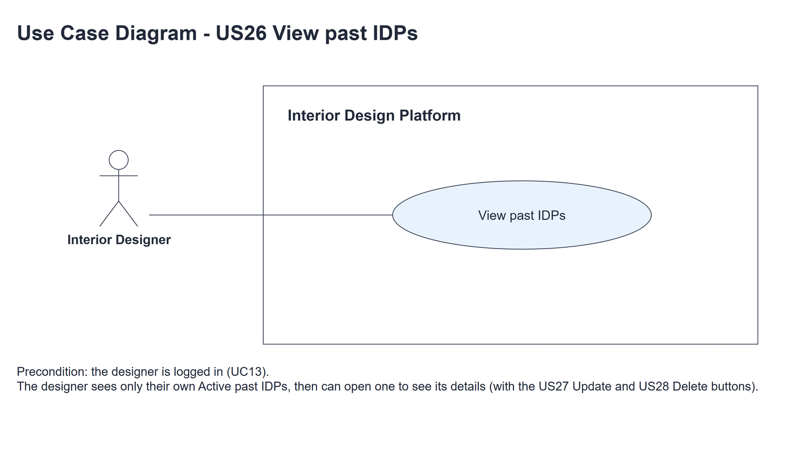
Figure 1: Use case diagram for US26 View past IDPs

3. Use case description
Use case | UC26 View past IDPs
Actor | Interior Designer
Brief description | The Interior Designer lists their past IDPs and opens one to check how it looks to customers.
User story | US26: As an interior designer, I want to view my past IDPs so that I can check how they look to customers.
Preconditions | The Interior Designer is logged in (UC13). designerLoginRequired in app.py only sends someone with no session to /designer/login.
Trigger | The Interior Designer clicks "Past IDPs" in the side menu or "View past IDPs" on the dashboard.
Basic flow | 1. The Interior Designer clicks "Past IDPs".  2. The system gets the designer's Active past IDPs, newest first.  3. The system shows the list with a "View" link for each IDP.  4. The Interior Designer clicks "View" on a past IDP.  5. The system gets that IDP if it is still the designer's Active past IDP.  6. The system shows its title, category, location and description as customers see them, with Update, Delete and "Back to past IDPs".
Alternative flows | 2a. The designer has no past IDPs: the system shows "You have no past IDPs yet". The use case ends.  5a. The IDP is missing, someone else's, Current or deleted: the system shows "Past IDP not found" (HTTP 404) with "Back to past IDPs". No details are shown.
Postconditions | Nothing is changed - no IDP and no customer view statistics.

4. Wireframes
The wireframes were drawn in draw.io. They are low-fidelity: they show the layout and the flow, not the final colours. The orange numbers match the notes under each screen.

4a - Past IDPs list
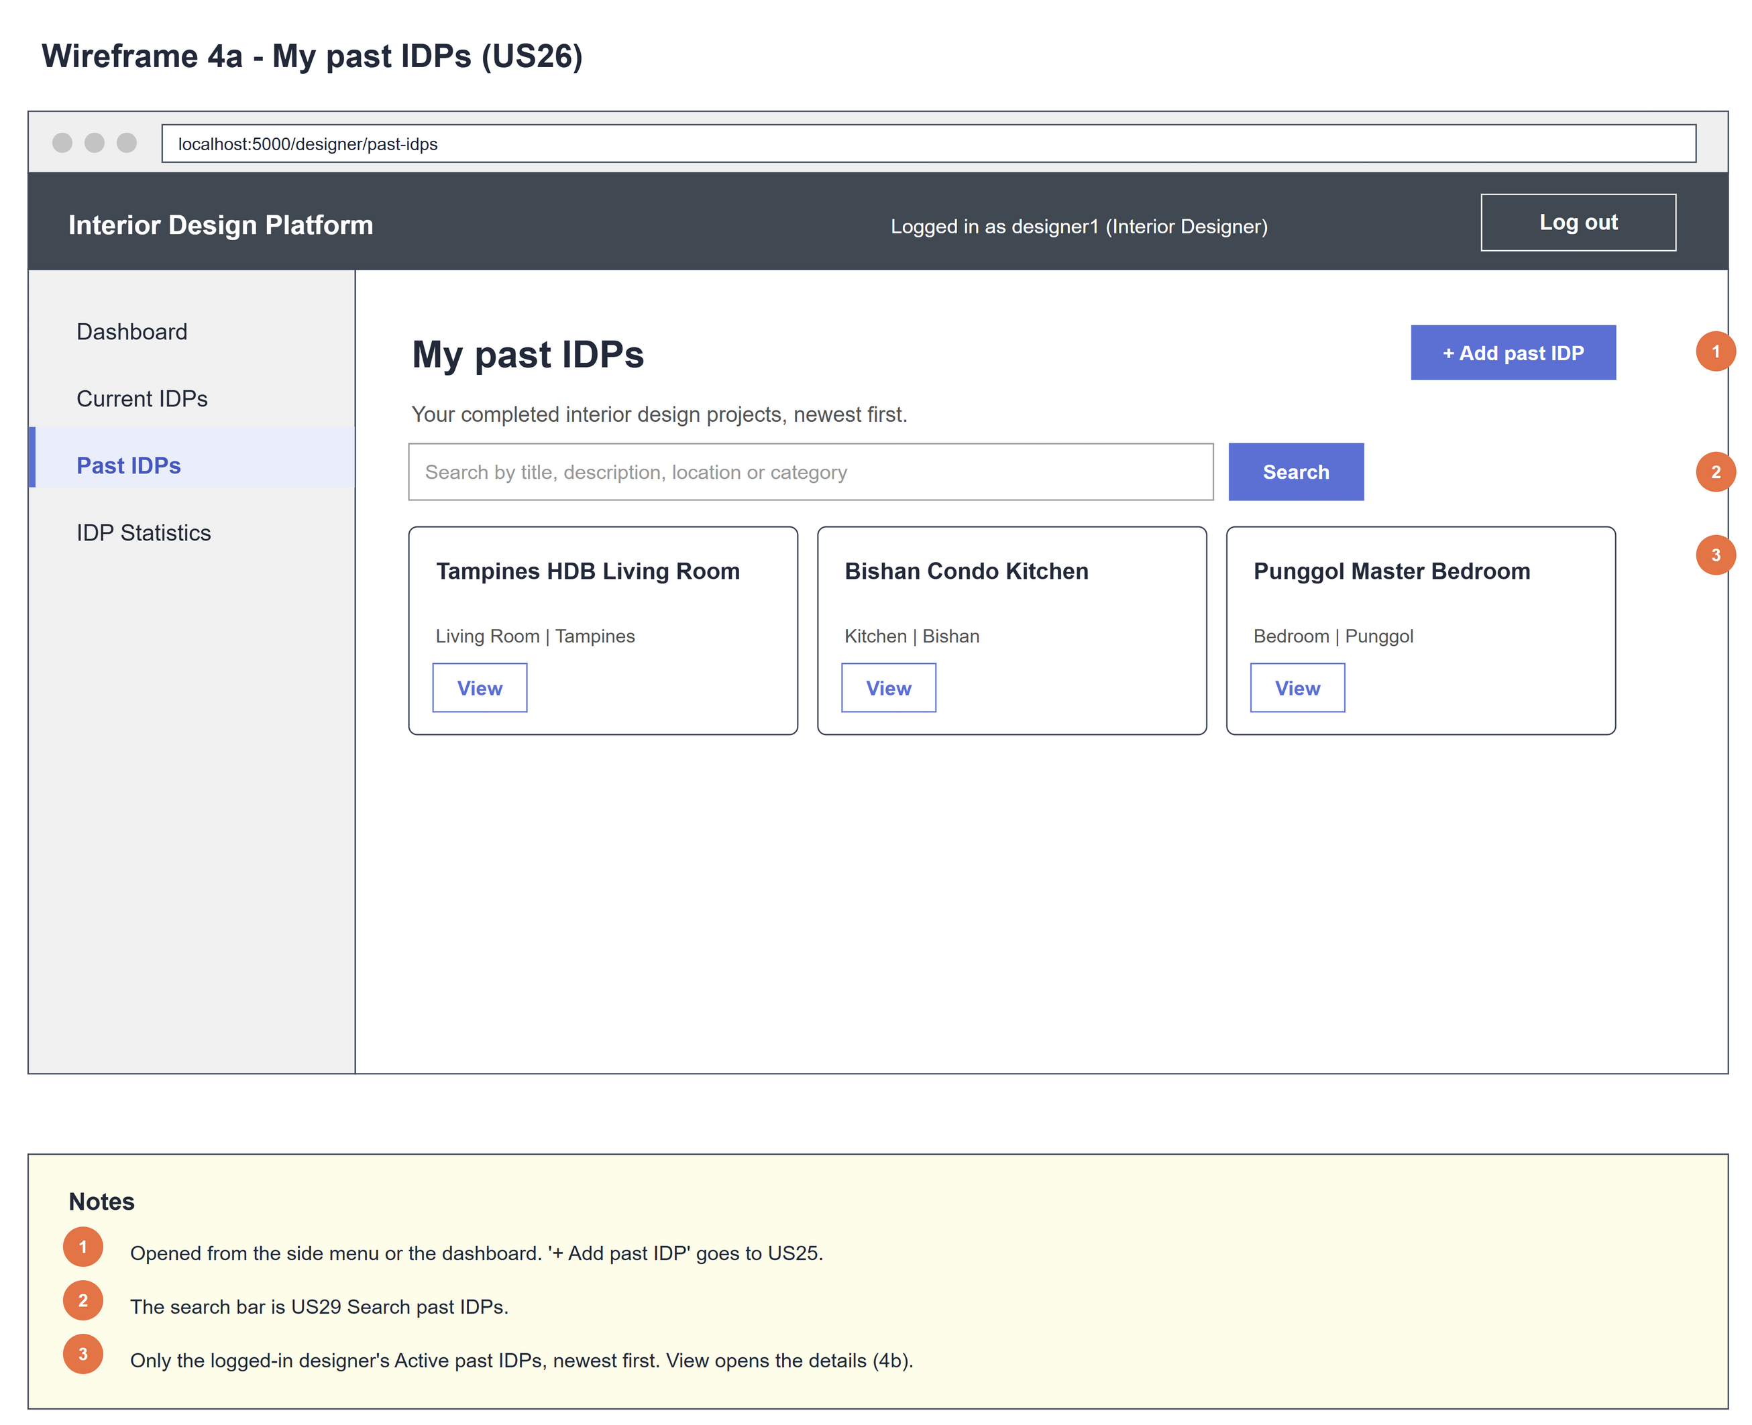
Figure 2: Wireframe 4a - Past IDPs list (US26)

4b - Past IDP details
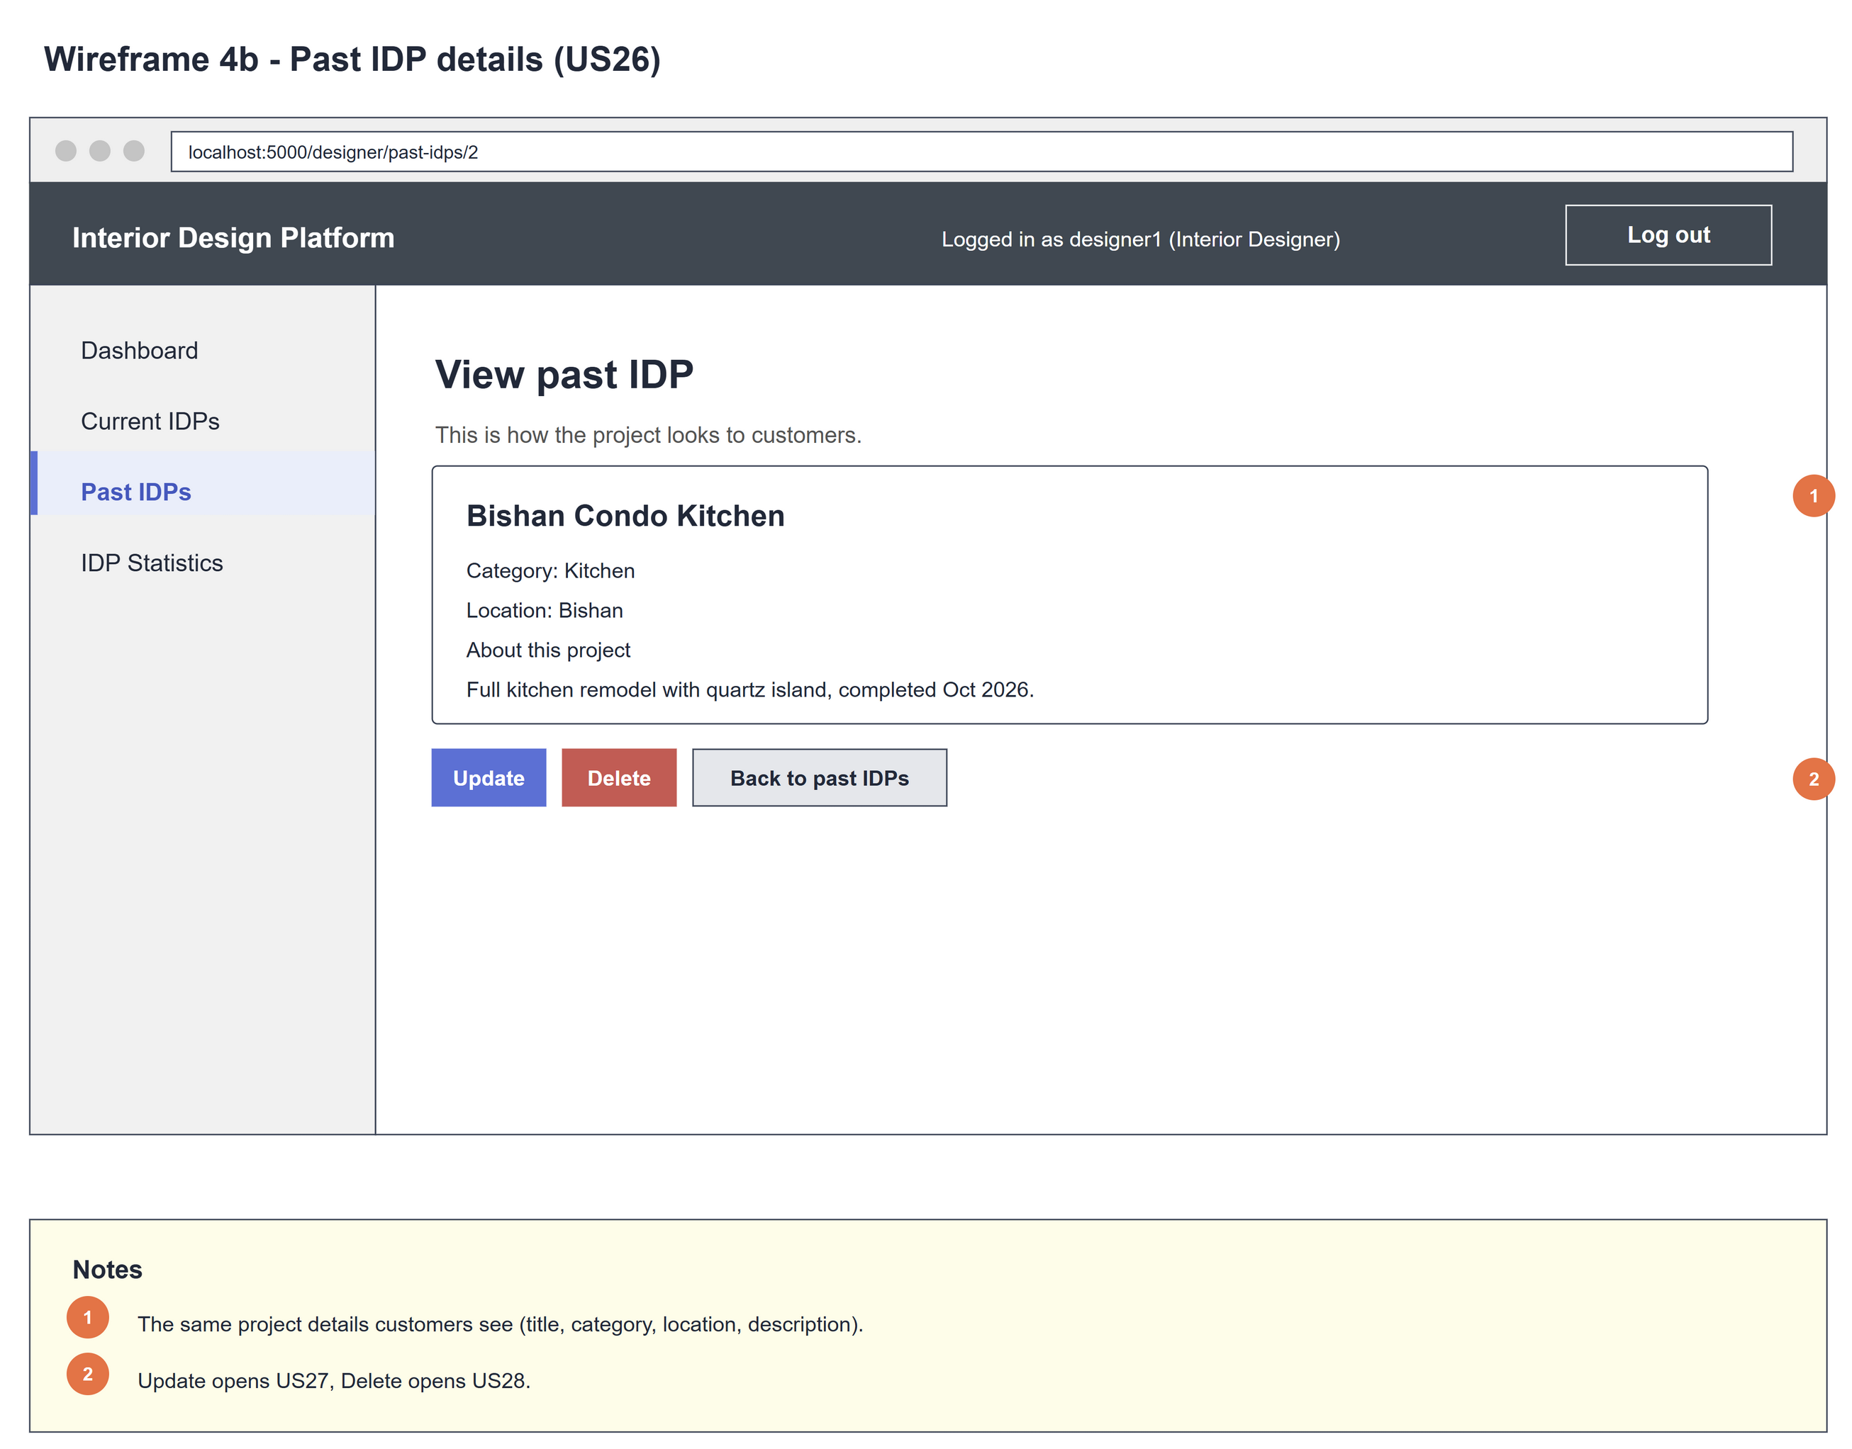
Figure 3: Wireframe 4b - Past IDP details (US26)

4c - No past IDPs yet
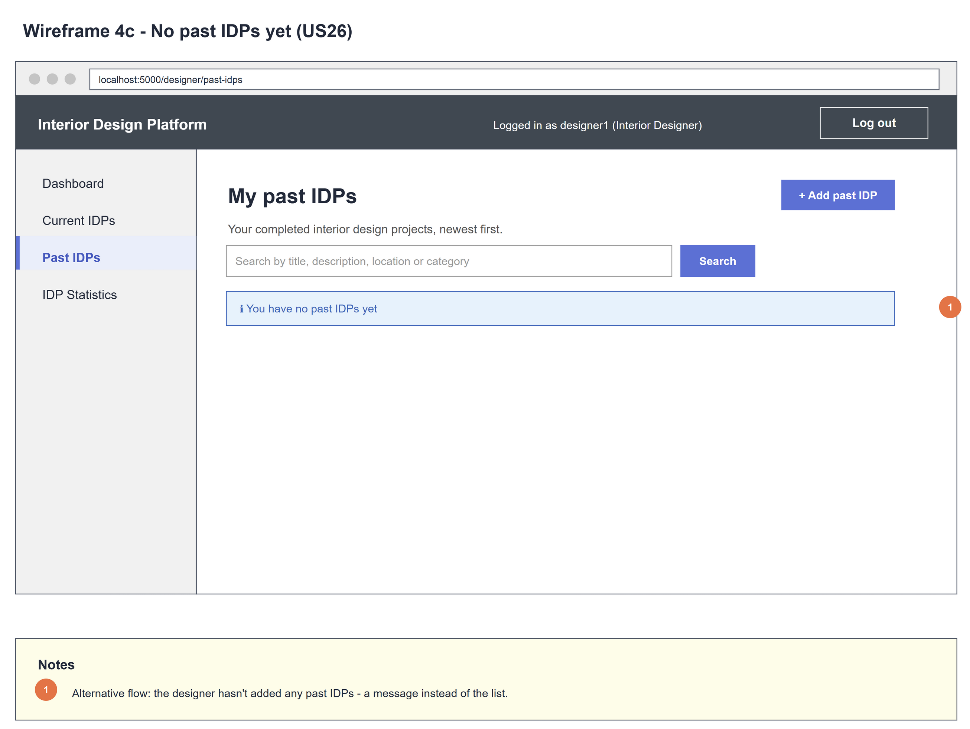
Figure 4: Wireframe 4c - No past IDPs yet (US26)

4d - Past IDP not found
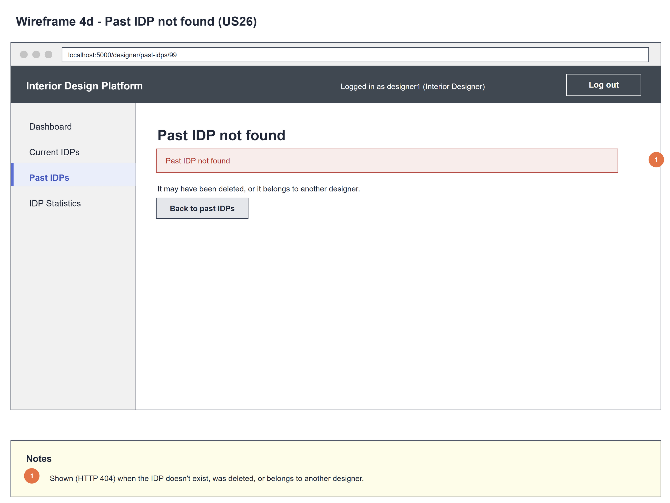
Figure 5: Wireframe 4d - Past IDP not found (US26)

5. B-C-E class diagram
The solid line means the boundary calls the controller. The dashed line means the controller uses the entity. Only the operations needed for this use case are shown. PastIDPListPage also holds the US28 delete methods (see US28).
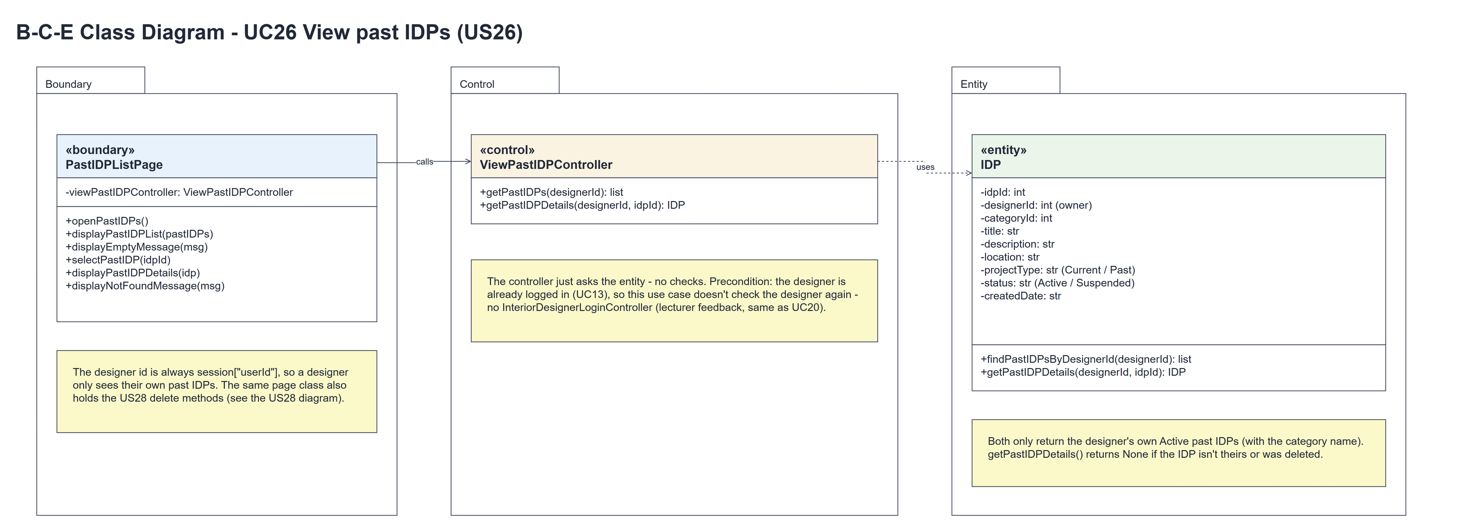
Figure 6: B-C-E class diagram for US26 View past IDPs
Layer | Class | What it does
Boundary | PastIDPListPage | The past IDPs list and details. openPastIDPs() calls the controller with designerId = session userId and shows displayPastIDPList(pastIDPs) or displayEmptyMessage(MSG_NO_PAST_IDPS). selectPastIDP(idpId) shows displayPastIDPDetails(idp) or displayNotFoundMessage(MSG_NOT_FOUND) (HTTP 404).
Control | ViewPastIDPController | Controller for UC26. getPastIDPs(designerId) and getPastIDPDetails(designerId, idpId) just call the entity and return the result - no checks.
Entity | IDP | The only entity. findPastIDPsByDesignerId(designerId) returns the owner's Active past IDPs (with the category name), newest first. getPastIDPDetails(designerId, idpId) returns one of them, or None.

6. Sequence diagram
The sequence diagram follows UC26. Clicking "Past IDPs" calls getPastIDPs(designerId), which makes one call to IDP.findPastIDPsByDesignerId() (steps 1-2); the first alt shows the list (step 3) or the empty message (2a). Clicking "View" calls getPastIDPDetails(designerId, idpId), which makes one call to IDP.getPastIDPDetails() (steps 4-5); the second alt shows the details (step 6) or the not-found page (5a).
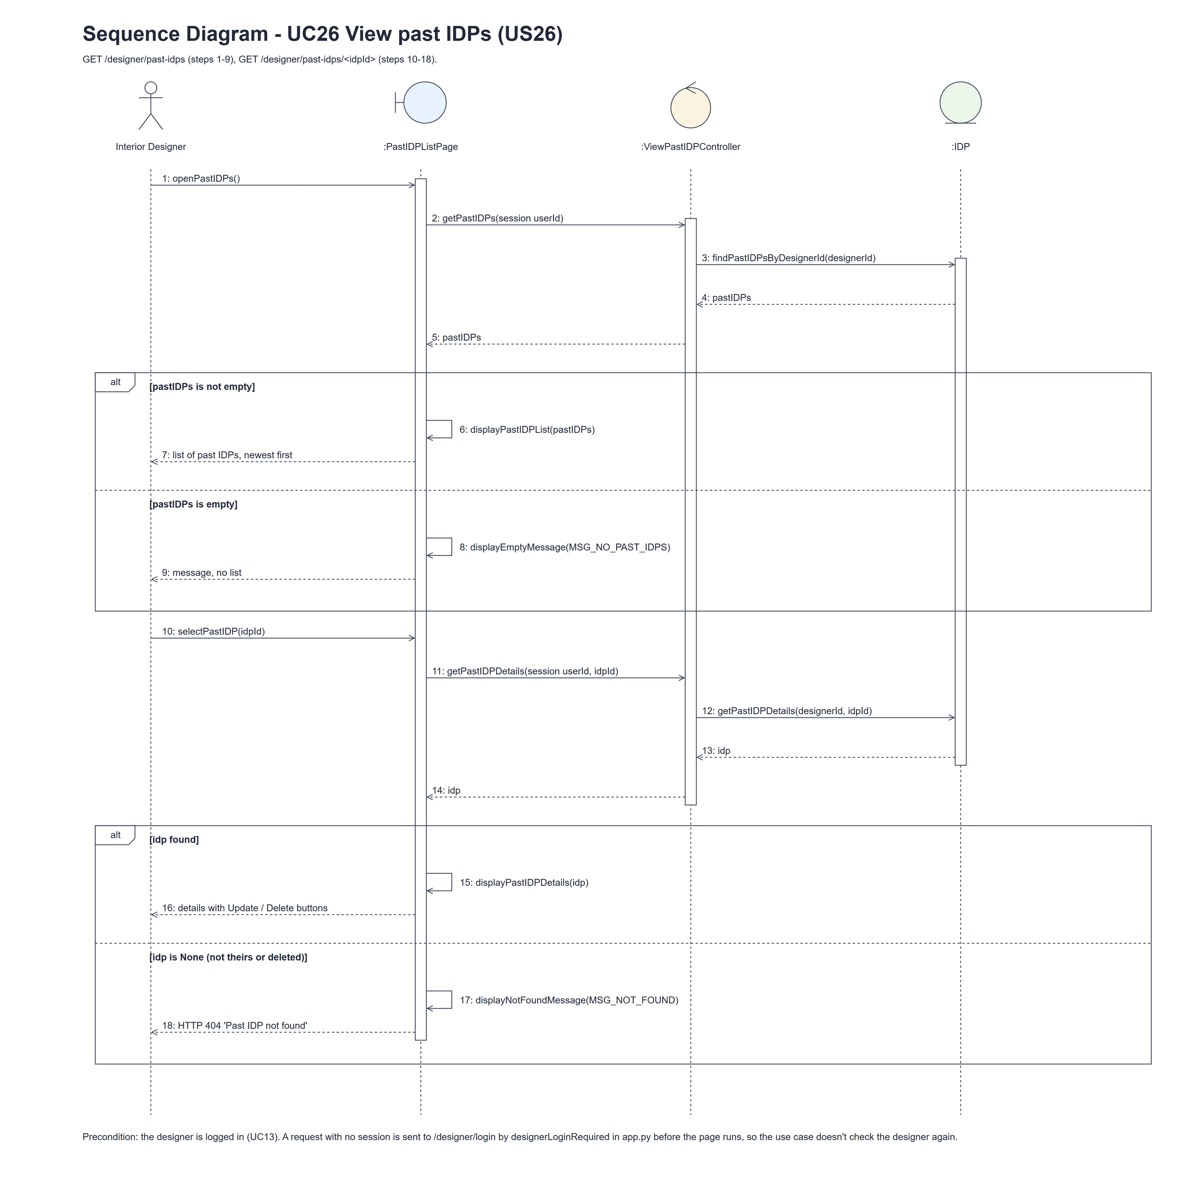
Figure 7: Sequence diagram for UC26 View past IDPs

7. Test cases
Test data used below (the same as tests/test_us26_viewPastIDPs.py, which reuses the US25 helpers): designer accounts designer37 (A) and designer26b (B) / Design@123, made with UC8. IDP category Kitchen (Active). A owns the past IDPs "Older Kitchen" and "Newer Kitchen", a deleted (Suspended) past IDP "Deleted Kitchen" and a current IDP "Current Kitchen"; B owns "Someone Else's Kitchen". Every test IDP has the description "Test project".

7a. System test cases (black box)
Equivalence partitioning and boundary value analysis were used to pick the test data. Fill in "Actual result" and "Pass/Fail" after running each test.
Test ID | Scenario | Prerequisites | Test steps | Test data | Expected result | Actual result | Pass / Fail
TC26.1 | View my past IDPs | Logged in as A. | 1. Click "Past IDPs" | A's and B's IDPs above | "My past IDPs" lists Newer Kitchen, then Older Kitchen, with category and location - not the deleted, current or B's IDP.
TC26.2 | Past IDP details | TC26.1 done. | 1. Click "View" on Newer Kitchen | - | Title, category, location and description, with Update, Delete and "Back to past IDPs".
TC26.3 | No past IDPs | Logged in as a designer with no past IDPs. | 1. Click "Past IDPs" | - | "You have no past IDPs yet".
TC26.4 | Someone else's IDP | Logged in as A. | 1. Open the details URL of B's IDP | B's idpId | HTTP 404 "Past IDP not found"; no details shown.
TC26.5 | Deleted, current or missing IDP | Logged in as A. | 1. Open the details URL of each | Deleted Kitchen, Current Kitchen, 999999 | HTTP 404 "Past IDP not found" each time.
TC26.6 | Links to past IDPs | Logged in as A. | 1. Open the dashboard | - | "Past IDPs" in the side menu, "View past IDPs" and "Add past IDP" on the dashboard.
TC26.7 | Not logged in | Not logged in. | 1. Open /designer/past-idps | - | The designer login page is shown.

7b. Unit test cases (for TDD)
These are written before the code (test-driven development) and run with pytest (python -m pytest). They cover normal inputs, abnormal inputs and boundary values. Each one matches a test function in tests/test_us26_viewPastIDPs.py (UT26.1 is test_ut26_1_...). "Pass" is from the pytest run on 10 November 2026.
Test ID | Class and method | Input / setup | Expected output | Type | Pass / Fail
UT26.1 | IDP.findPastIDPsByDesignerId(designerId) | A: Older, Newer, Deleted (Suspended), Current; B's past IDP | [Newer, Older] - only A's Active past IDPs, newest first | Normal | Pass
UT26.2 | IDP.findPastIDPsByDesignerId(designerId) | A's past IDP in Kitchen | categoryName "Kitchen" is joined | Normal | Pass
UT26.3 | IDP.getPastIDPDetails(designerId, idpId) | A's IDP as A; as B; idpId 999999 | The IDP; None; None | Abnormal | Pass
UT26.4 | ViewPastIDPController.getPastIDPs() and getPastIDPDetails() | A's past IDP | Each makes one entity call and returns the result | Normal | Pass
UT26.5 | PastIDPListPage.openPastIDPs() | A has "Completed Kitchen" | "My past IDPs" with Completed Kitchen | Normal | Pass
UT26.6 | PastIDPListPage.displayEmptyMessage() | A has no past IDPs | "You have no past IDPs yet" | Boundary | Pass
UT26.7 | PastIDPListPage.selectPastIDP() | A's past IDP | Title, category, description and the Update (/edit) and Delete (/delete) links | Normal | Pass
UT26.8 | PastIDPListPage.displayNotFoundMessage() | B's past IDP | HTTP 404 "Past IDP not found" | Abnormal | Pass
UT26.9 | /designer/past-idps (designerLoginRequired) | Not logged in | Redirects to /designer/login | Abnormal | Pass
UT26.10 | Designer dashboard | A opens it | Two links to /designer/past-idps (menu and dashboard) and one to /designer/past-idps/add | Normal | Pass

